Serbia
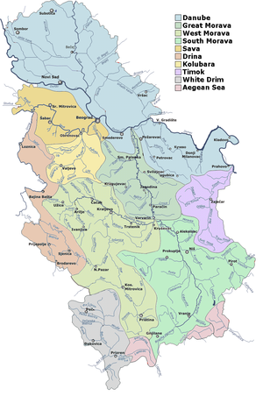
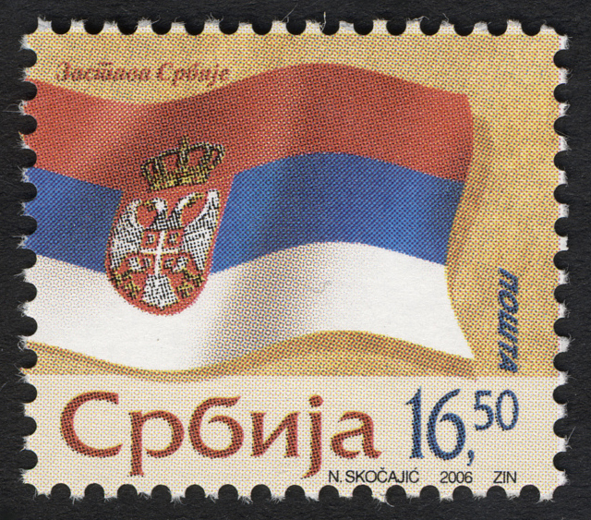
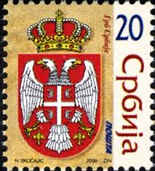
Chronology
18 Jan 395 Part of Eastern Roman (Byzantine) Empire.
7th cent. Settled predominantly by Slavs, under Greek
suzerainty.
83. - 96. Serb state, autonomous within the Eastern Roman
(Byzantine) Empire.
924 - 931 Bulgarian occupation.
96. - 997 Part of autonomous Dioclea (Diókleia) within
Byzantine (Eastern Roman) Empire (see Montenegro)
997 - Mar? 1018 Part of Bulgaria.
Mar? 1018 - 1071 Byzantine rule as the theme of Sirmium (Sirmíou).
1071 - 1091 Part of Dioclea (see Montenegro) by force
(presumably coinciding with Hungarian capture of
Sirmium).
1091 Separated from Dioclea (by civil war); state is
often referred to by historians as "Raška/Rascia"
1126 Under Byzantine suzerainty (by force).
8 Aug 1217 Serbian Kingdom (by papal coronation).
16 Apr 1346 - 3 Dec 1371 Serbian Empire, main capital at Skopje.
Sep? 1365 The coronation of king Vukašin is not recognized
by most provincial leaders, resulting in the
disintegration of the Serbian state.
1371 - 17 May 1395 Serbian rulers at Velbužd and Prilep become
Ottoman vassals.
1390 - 18 Aug 1439 Serbia an Ottoman vassal.
17 May 1395 Ottomans annex Velbužd and Prilep.
Aug 1402 Despotate of Serbia
Jul 1427 - 29 Aug 1521 Belgrade part of Hungary.
18 Aug 1439 - 12 Jun 1444 Ottoman occupation.
12 Jun 1444 Serbia restored by Hungarian forces (peace treaty
effective 22 Aug 1444).
20 Jun 1459 Part of Ottoman Empire (part of Rumelia Eyalet;
as sanjak of Semendire [Smederevo], from 1521
also called "Belgrade Pashaluk").
29 Aug 1521 Ottomans annex Belgrade.
1594 Serb rebellion (Banat uprising).
1597 - 1598 Serb rebellion (Grdan's uprising).
6 Sep 1689 - 10 Sep 1691 Austrian occupation.
22 Aug 1717 - 4 Sep 1739 Austrian occupation, from 1718 organized as Kingdom
of Serbia (Königreich Serbien) within Austria.
9 Feb 1778 - 7 Sep 1778 Serb rebellion (Koča's Krajina rebellion).
Aug 1789 - Sep 1791 Austrian occupation.
2 Feb 1804 - 21 Sep 1813 Serbia (Srbija); uprising against Ottoman rule
(New Style dates 14 Feb 1804 - 3 Oct 1813)
21 Sep 1813 Ottoman rule restored (New Style 3 Oct 1813).
11 Apr 1815 - 14 Jul 1817 Second Serb uprising against Ottoman rule (New Style
dates 23 Apr 1815 - 26 Jul 1817).
9 Nov 1815 Serbia (Srbija)(officially from 25 Oct 1817 under
Ottoman suzerainty)(New Style dates 21 Nov 1815
and 6 Nov 1817).
30 Nov 1830 Principality of Serbia (Servië)(Knjaževstvo Srbija),
autonomous under Ottoman suzerainty (New Style
date 12 Dec 1830).
1831 - 1833 Expansion of Serbia southwards to Kruševac.
19 Apr 1867 Ottomans evacuate Kalemegdan fortress in Belgrade
(Old style date 6 Apr 1867).
3 Jul 1868 Modern Serbian orthography introduced (Old style
date 21 Jun 1868).
1877 - 1878 Serbia expands south to Nish (Niš), Pirot, and
Toplica (Toplitsa).
13 Jul 1878 Independence recognized (Old Style date 1 Jul 1878
ratified 3 Aug 1878/22 Jul 1878).
6 Mar 1882 Kingdom of Serbia (Kraljevina Srbija)(Old style
date 22 Feb 1882).
10 Aug 1913 Southern Serbia, Novi Pazar and Macedonia annexed
from Ottoman Empire.
11 Aug 1914 - 21 Aug 1914 Austro-Hungarian occupation of northwestern
Serbia.
2 Dec 1914 - 15 Dec 1914 Belgrade occupied by Austria-Hungary.
9 Oct 1915 - 1 Nov 1918 Serbia occupied by Austria-Hungary and Bulgaria
(in Vranje to 5 Oct 1918, Niš to 11 Oct 1918).
1 Dec 1918 Kingdom of Serbs, Croats and Slovenes (Kraljevstvo
Srba, Hrvata i Slovenaca)(proclamation of
the unification of Serbia and the State of
Slovenes, Croats and Serbs into a single kingdom
by public ceremony in Belgrade)(see Yugoslavia)
(Old Style date 18 Nov 1918).
29 Dec 1918 Parliament of Serbia approves act of unification.
4 Oct 1929 Kingdom of Yugoslavia (Kraljevina Jugoslavija).
Serbia is divided into Vardarska banovina [Banate
of the Vardar: see Macedonia], Zetska banovina
[Banate of the Zeta: see Montenegro], Dunavska
banovina [Banate of the Danube: see Vojvodina],
Moravska banovina [Banate of the Morava], and
City of Belgrade).
13 Apr 1941 - 20 Oct 1944 Serbia and Banat occupied by Germany (Military
Administration in Serbia [Militärverwaltung in
Serbien])(from 30 Apr 1941, Serbian state
officially named "Serbia" [Srbija]).
17 Apr 1941 Capitulation of Yugoslav forces and collapse of
central government.
31 Dec 1941 - 20 Sep 1944 Bulgaria occupies Vardar Macedonia and Southern
Pomoravlje (subordinate to German forces).
29 Nov 1943 Yugoslav state declared reconstituted (in
rebellion) as Democratic Federative Yugoslavia
(while negotiations with exile royal government).
29 Nov 1943 Serbia declared re-incorporated into Yugoslavia
(in rebellion).
20 Oct 1944 Belgrade is liberated.
9 Nov 1944 Serbia (Srbija).
29 Nov 1945 Part of Federal People's Republic of Yugoslavia.
31 Jan 1946 People's Republic of Serbia (Narodna Republika
Srbija)(within Yugoslavia).
7 Apr 1963 Socialist Republic of Serbia (Socijalistička
Republika Srbija)(within Yugoslavia).
28 Sep 1990 Republic of Serbia (Republika Srbija)(within
Yugoslavia).
27 Apr 1992 - 4 Feb 2003 Federal Republic of Yugoslavia (Serbia and
Montenegro only) .
12 Jun 1999 Kosovo under foreign occupation (United Nations
administration).
4 Feb 2003 Serbia and Montenegro (Serbia and Montenegro form a
state union).
5 Jun 2006 Independence, Serbia acknowledges end of the
union, declaring itself its legal successor.
17 Feb 2008 Kosovo declares independence (not recognized
by Serbia).
Secretaries of the Central Committee of the Communist Party
(from 1952, League of Communists)
1941 - 1948 Blagoje Neskovic (b. 1907 - d. 1984)
1948 - Mar 1957 Petar Stambolic (b. 1912 - d. 2007)
Mar 1957 - 4 Nov 1966 Jovan Veselinov (b. 1906 - d. 1982)
Chairmen of the Central Committee of the League of Communists
4 Nov 1966 - 19 Jan 1968 Dobrivoje Radosavljevic (b. 1915 - d. 1984)
19 Jan 1968 - Nov 1968 Petar Stambolic (s.a.)
Nov 1968 - 26 Oct 1972 Marko Nikezic (b. 1921 - d. 1991)
26 Oct 1972 - May 1982 Tihomir Vlaskalic (b. 1923 - d. 1993)
May 1982 - 17 May 1984 Dusan Ckrebic (b. 1927)
May 1984 - May 1986 Ivan Stambolic (b. 1936 - d. 2000)
May 1986 - 24 May 1989 Slobodan Milosevic (b. 1941 - d. 2006)
24 May 1989 - 16 Jul 1990 Bogdan Trifunovic (b. 1933 - d. 2007)
Chief (from 26 Dec 1808, Supreme Chief)
14 Feb 1804 - 3 Oct 1813 Karadjordje (b. 1762 - d. 1817)
Princes
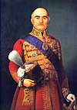 | 21 Nov 1815 - 13 Jun 1839 Milos Obrenovic I (1st time)  (b. 1780 - d. 1860)
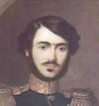 | 13 Jun 1839 - 8 Jul 1839 Milan Obrenovic II  (b. 1819 - d. 1839)
15 Jun 1839 - 17 Mar 1840 Provisional Regency
(for incapacitated Milan to 8 Jul 1839)
- Jevrem Obrenovic (b. 1790 - d. 1856)
- Toma Vucic Perisic (b. 1787 - d. 1859)
- Avram Petronijevic (b. 1791 - d. 1852)
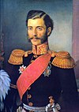 | 17 Mar 1840 - 14 Sep 1842 Mihailo Obrenovic III (1st time)  (b. 1823 - d. 1868)
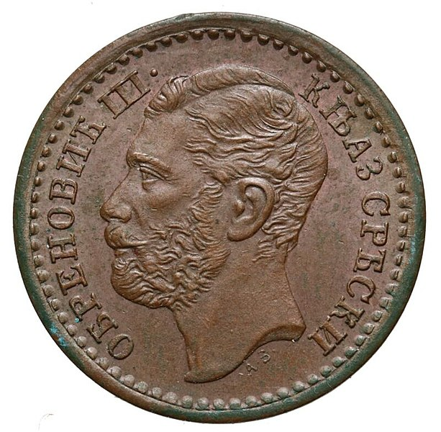
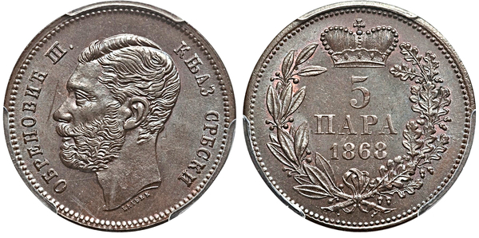
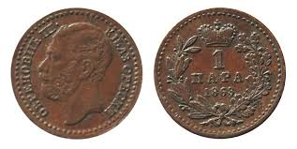
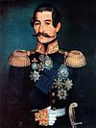 | 14 Sep 1842 - 20 Jun 1843 Aleksandar Karadjordjevic  (1st time) (b. 1806 - d. 1885)
20 Jun 1843 - 27 Jun 1843 Regency
- Stefan Stefanovic Tenka (b. 1797 - d. 1865)
- Lazar Teodorovic (b. 1781 - d. 1846)
- Milosav Zdravkovic (b. 1788 - d. 1854)
27 Jun 1843 - 23 Dec 1858 Aleksandar Karadjordjevic
(2nd time) (s.a.)
23 Dec 1858 - 24 Dec 1858 Misa Anastasijevic
(b. 1803 - d. 1885)
(president of Assembly of St. Andrew)
 | 24 Dec 1858 - 26 Sep 1860 Milos Obrenovic I (2nd time) (s.a.)
 | 26 Sep 1860 - 10 Jun 1868 Mihailo Obrenovic III (2nd time) (s.a.)
10 Jun 1868 - 2 Jul 1868 Provisional Regency
- Jovan Marinovic (b. 1821 - d. 1893)
- Rajko Lesjanin (b. 1826 - d. 1872)
- Djordje Petrovic
2 Jul 1868 - 6 Mar 1882 Milan Obrenovic IV
(b. 1854 - d. 1901)
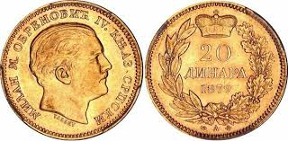
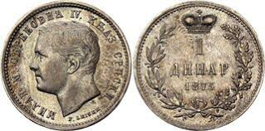
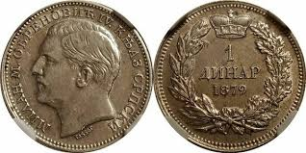
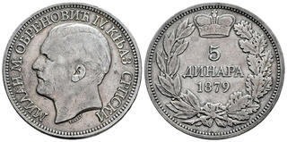
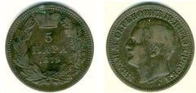
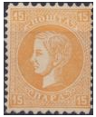 |  |  | 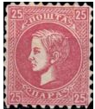
2 Jul 1868 - 22 Aug 1872 Regency
- Milivoje Petrovic Blaznavac (b. 1824 - d. 1873)
- Jovan Ristic (b. 1831 - d. 1899)
- Jovan Gavrilovic (b. 1796 - d. 1877)
Kings
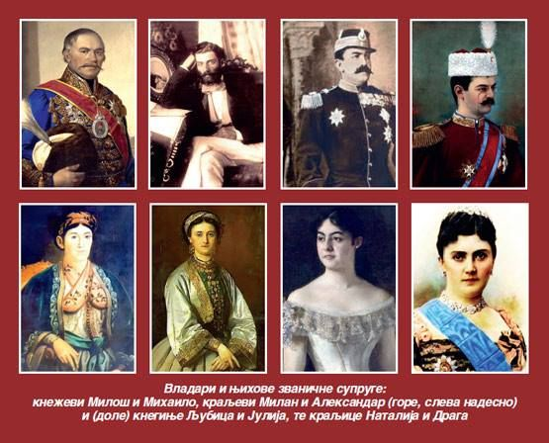
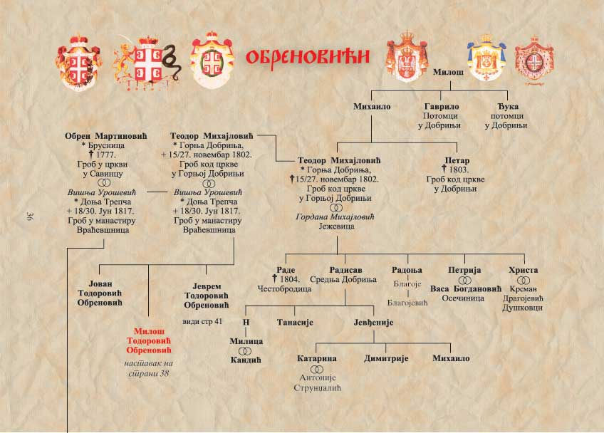
- Obrenovic dynasty -
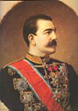 | 6 Mar 1882 - 6 Mar 1889 Milan I (s.a.)
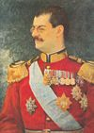 | 6 Mar 1889 - 11 Jun 1903 Aleksandar I  (b. 1876 - d. 1903)
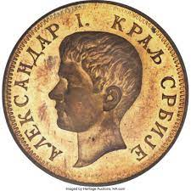
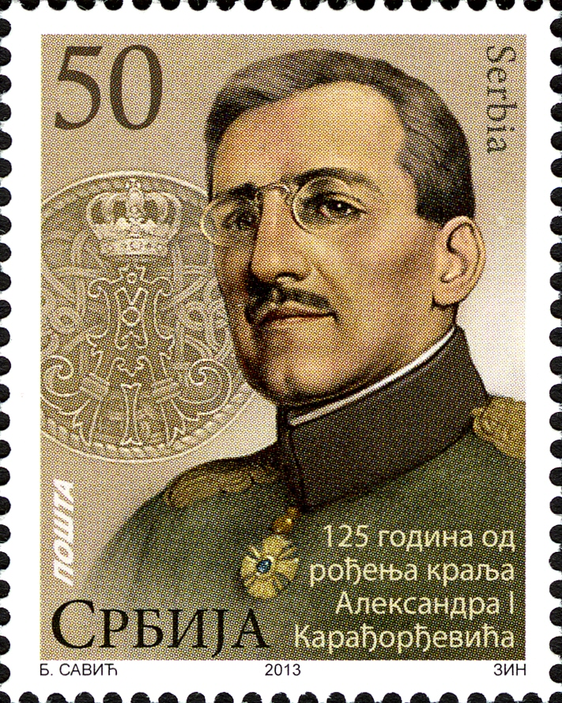
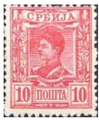 |  |  | 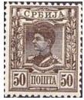
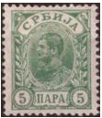 |  |  | 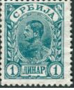
6 Mar 1889 - 13 Apr 1893 Regency
- Jovan Ristic (s.a.)
- Jovan Belimarkovic (b. 1827 - d. 1906)
- Kosta Protic (to 16 Jun 1892) (b. 1831 - d. 1892)
11 Jun 1903 - 15 Jun 1903 Jovan Avakumovic (regent)
(b. 1841 - d. 1928)
- Karadjordjevic dynasty -
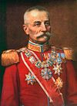 | 15 Jun 1903 - 1 Dec 1918 Petar I  (b. 1844 - d. 1921)
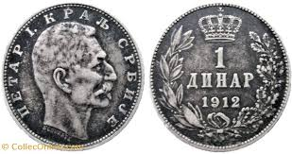
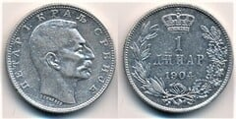
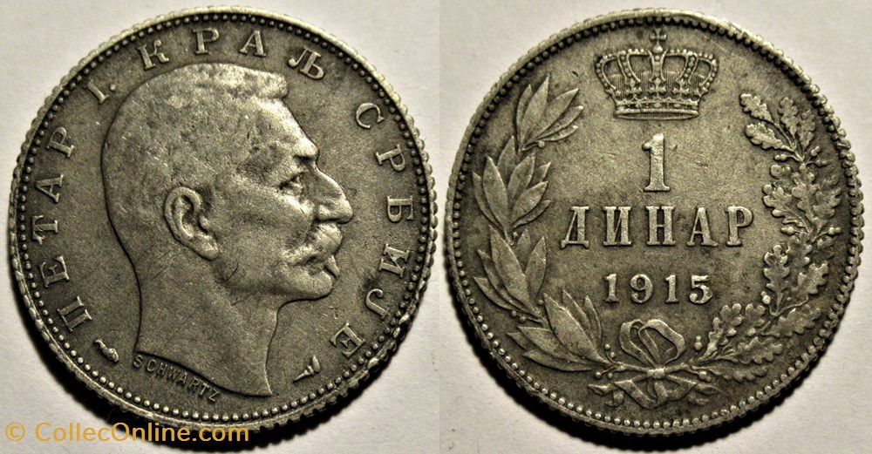
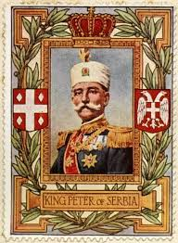
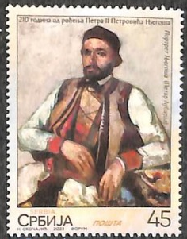
5 Jul 1914 - 1 Dec 1918 Prince Aleksandar (regent)
(b. 1888 - d. 1934)
29 Aug 1941 - 20 Oct 1944 government under German occupation
carried on in the name of the
absent and non-consenting King
 | Petar II (b. 1923 - d. 1970)
German military governors
20 Apr 1941 - 1 Jun 1941 Helmuth Förster
(b. 1889 - d. 1965)
1 Jun 1941 - 28 Jul 1941 Ludwig von Schröder
(b. 1884 - d. 1941)
29 Jul 1941 - 19 Sep 1941 Heinrich Danckelmann
(b. 1887 - d. 1947)
19 Sep 1941 - 7 Dec 1941 Franz Böhme
(b. 1894 - d. 1947)
7 Dec 1941 - 26 Aug 1943 Paul Bader
(b. 1883 - d. 1971)
26 Aug 1943 - 20 Oct 1944 Hans-Gustav Felber
(b. 1889 - d. 1962)
President of the Presidium of the People's Assembly
(until 7 Apr 1945, chairman of the Anti-Fascist Assembly of People's Liberation)
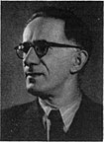 | 12 Nov 1944 - Mar 1953 Sinisa Stankovic  (b. 1892 - d. 1974)
Presidents of the National Assembly
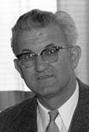 | Dec 1953 - Apr 1957 Petar Stambolic (s.a.)
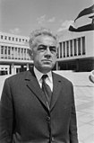 | Apr 1957 - 26 Jun 1963 Jovan Veselinov (s.a.)
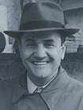 | 26 Jun 1963 - 6 May 1967 Dusan Petrovic  (b. 1914 - d. 1977)
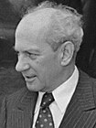 | 6 May 1967 - 6 May 1969 Milos Minic  (b. 1914 - d. 2003)
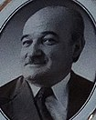 | 6 May 1969 - 19 Apr 1974 Dragoslav Markovic  (b. 1920 - d. 2005)
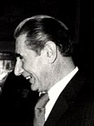 | 19 Apr 1974 - 6 May 1974 Zivan Vasiljevic  (b. 1920 - d. 2007)
Presidents of the Presidency
 | 6 May 1974 - 5 May 1978 Dragoslav Markovic (s.a.)
5 May 1978 - 5 May 1982 Dobrivoje Vidic
(b. 1918 - d. 1992)
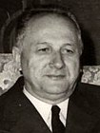 | 5 May 1982 - May 1984 Nikola Ljubicic  (b. 1916 - d. 2005)
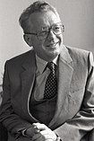 | May 1984 - May 1986 Dusan Ckrebic (s.a.)
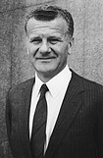 | May 1986 - 14 Dec 1987 Ivan Stambolic (s.a.)
14 Dec 1987 - 20 Mar 1989 Petar Gracanin
(b. 1923 - d. 2004)
20 Mar 1989 - 8 May 1989 Ljubisa Igic (acting)
(b. 1941)
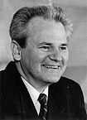 | 8 May 1989 - Jan 1991 Slobodan Milosevic (s.a.)
Presidents
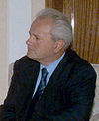 |  | Jan 1991 - 23 Jul 1997 Slobodan Milosevic (s.a.)
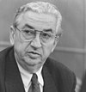 |  | 23 Jul 1997 - 29 Dec 1997 Dragan Tomic (acting)  (b. 1936)
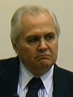 |  | 29 Dec 1997 - 29 Dec 2002 Milan Milutinovic  (b. 1942)
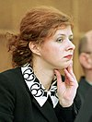 |  | 30 Dec 2002 - 27 Jan 2004 Natasa Micic (f) (acting)  (b. 1965)
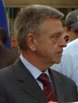 |  | 4 Feb 2004 - 3 Mar 2004 Dragan Marsicanin (acting)  (b. 1950)
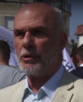 |  | 3 Mar 2004 - 4 Mar 2004 Vojislav Mihailovic (acting)  (b. 1951)
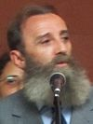 |  | 4 Mar 2004 - 11 Jul 2004 Predrag Markovic (acting)  (b. 1955)
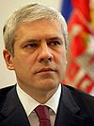 |  | 11 Jul 2004 - 5 Apr 2012 Boris Tadic  (b. 1958)
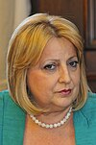 |  | 5 Apr 2012 - 31 May 2012 Slavica Djukic Dejanovic (f)  (b. 1951) (acting)
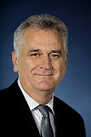 |  | 31 May 2012 - 31 May 2017 Tomislav Nikolic  (b. 1952)
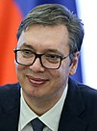 |  | 31 May 2017 - Aleksandar Vucic  (b. 1970)
Presidents of the Administering Council
25 Aug 1805 - Oct 1805 Jovan Protic (acting)
(b. 1770 - d. 1827)
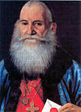 |  | Oct 1805 - mid-1806 Mateja Nenadovic  (b. 1777 - d. 1854)
 |  | mid-1806 - Jan 1808 Karadjordje (1st time) (s.a.)
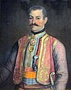 |  | Jan 1808 - Nov 1809 Mladen Milovanovic  (b. 1760 - d. 1823)
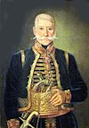 |  | Nov 1809 - 22 Jan 1811 Jakov Nenadovic  (b. 1765 - d. 1836)
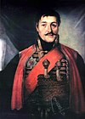 |  | 22 Jan 1811 - 3 Oct 1813 Karadjordje (2nd time) (s.a.)
Prince's representatives
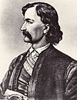 |  | 21 Nov 1815 - 16 May 1816 Petar Nikolajevic Moler  (b. 1775 - d. 1816)
 |  | 1818 - 1820 Avram Petronijevic (1st time) (s.a.)
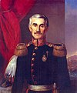 |  | 1821 - 1826 Jevrem Obrenovic  (b. 1790 - d. 1856)
 |  | 1826 Avram Petronijevic (2nd time) (s.a.)
1826 Miloje Todorovic
(b. 1762 - d. 1832)
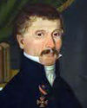 |  | 1826 - 1835 Dimitrije Davidovic  (b. 1789 - d. 1839)
1835 - 1839 Jakov Zivanovic
(b. 1808 - d. 1861)
Prime ministers
15 Feb 1835 - 1836 Koca Markovic
(b. 1795 - d. 1836)
 |  | 28 Mar 1836 - 26 Feb 1839 Stefan Stefanovic Tenka (s.a.)
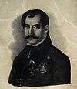 |  | 26 Feb 1839 - 8 May 1840 Avram Petronijevic (1st time) (s.a.)
8 May 1840 - 15 May 1840 Paun Jankovic (acting)
(b. 1808 - d. 1865)
15 May 1840 - 8 Sep 1842 Djordje Protic
(b. 1793 - d. 1857)
 |  | 8 Sep 1842 - 20 Jun 1843 Avram Petronijevic (2nd time) (s.a.)
20 Jun 1843 - 29 Nov 1843 Aleksa Jankovic (1st time)
(b. 1806 - d. 1869)
(acting [for Simic from 6 Oct 1843])
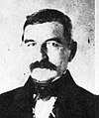 |  | 6 Oct 1843 - 11 Oct 1844 Aleksa Simic (1st time)  (b. 1800 - d. 1872)
 |  | 11 Oct 1844 - 22 Apr 1852 Avram Petronijevic (3rd time) (s.a.)
Oct 1851 - 25 Sep 1852 Aleksa Jankovic (2nd time) (s.a.)
(acting [for Petronijevic to 22 Apr 1852])
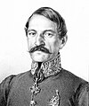 |  | 25 Sep 1852 - 26 Mar 1853 Ilija Garasanin (1st time)  (b. 1812 - d. 1874)
 |  | 26 Mar 1853 - 28 Dec 1855 Aleksa Simic (2nd time) (s.a.)
 |  | 28 Dec 1855 - 10 Jun 1856 Aleksa Jankovic (3rd time) (s.a.)
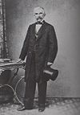 |  | 10 Jun 1856 - 28 Sep 1856 Stefan Markovic (1st time)  (b. 1804 - d. 1864) (acting)
 |  | 28 Sep 1856 - 1 Jul 1857 Aleksa Simic (3rd time) (s.a.)
 |  | 1 Jul 1857 - 12 Apr 1858 Stefan Markovic (2nd time) (s.a.)
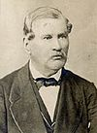 |  | 12 Apr 1858 - 18 Apr 1859 Stefan Magazinovic (acting)  (b. 1804 - d. 1874)
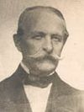 |  | 18 Apr 1859 - 8 Nov 1860 Cvetko Rajovic  (b. 1793 - d. 1873)
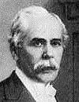 |  | 8 Nov 1860 - 21 Oct 1861 Filip Hristic  (b. 1819 - d. 1905)
 |  | 21 Oct 1861 - 15 Nov 1867 Ilija Garasanin (2nd time) (s.a.)
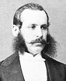 |  | 15 Nov 1867 - 3 Dec 1867 Jovan Ristic (1st time) (s.a.)
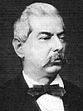 |  | 3 Dec 1867 - 3 Jul 1868 Nikola Hristic (1st time)  (b. 1816 - d. 1911)
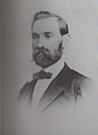 |  | 3 Jul 1868 - 8 Aug 1869 Djordje Cenic  (b. 1825 - d. 1903)
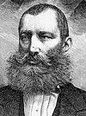 |  | 8 Aug 1869 - 22 Aug 1872 Radivoje Milojkovic  (b. 1832 - d. 1888)
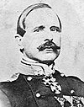 |  | 22 Aug 1872 - 5 Apr 1873 Milivoje Petrovic Blaznavac (s.a.)
5 Apr 1873 - 3 Nov 1873 Jovan Ristic (2nd time) (s.a.)
(acting to 14 Apr 1873)
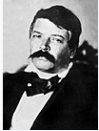 |  | 3 Nov 1873 - 7 Dec 1874 Jovan Marinovic (s.a.)
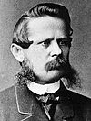 |  | 7 Dec 1874 - 3 Feb 1875 Acim Cumic  (b. 1836 - d. 1901)
3 Feb 1875 - 31 Aug 1875 Danilo Stefanovic
(b. 1815 - d. 1886)
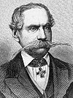 |  | 31 Aug 1875 - 8 Oct 1875 Stevca Mihailovic (1st time)  (b. 1804 - d. 1888)
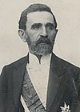 |  | 8 Oct 1875 - 6 May 1876 Ljubomir Kaljevic  (b. 1841 - d. 1907)
 |  | 6 May 1876 - 13 Oct 1878 Stevca Mihailovic (2nd time) (s.a.)
 |  | 13 Oct 1878 - 2 Nov 1880 Jovan Ristic (3rd time) (s.a.)
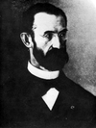 |  | 2 Nov 1880 - 13 Oct 1883 Milan Pirocanac  (b. 1837 - d. 1897)
 |  | 13 Oct 1883 - 1 Mar 1884 Nikola Hristic (2nd time) (s.a.)
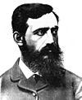 |  | 1 Mar 1884 - 13 Jun 1887 Milutin Garasanin  (b. 1843 - d. 1898)
 |  | 13 Jun 1887 - 31 Dec 1887 Jovan Ristic (4th time) (s.a.)
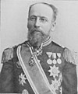 |  | 31 Dec 1887 - 26 Apr 1888 Sava Grujic (1st time)  (b. 1840 - d. 1913)
 |  | 26 Apr 1888 - 6 Mar 1889 Nikola Hristic (3rd time) (s.a.)
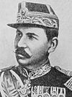 |  | 6 Mar 1889 - 7 Mar 1889 Kosta Protic (s.a.)
 |  | 7 Mar 1889 - 23 Feb 1891 Sava Grujic (2nd time) (s.a.)
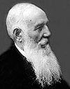 |  | 23 Feb 1891 - 21 Aug 1892 Nikola Pasic (1st time)  (b. 1845 - d. 1926)
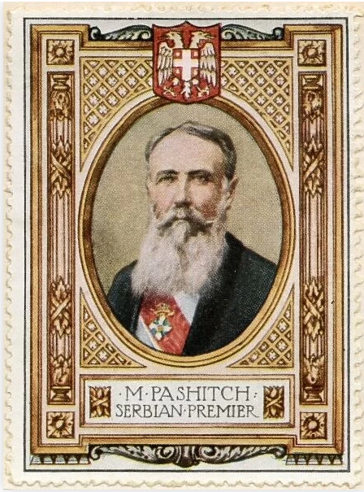
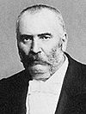 |  | 21 Aug 1892 - 13 Apr 1893 Jovan Avakumovic (1st time) (s.a.)
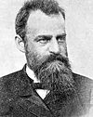 |  | 13 Apr 1893 - 5 Dec 1893 Lazar Dokic  (b. 1845 - d. 1893)
 |  | 5 Dec 1893 - 24 Jan 1894 Sava Grujic (3rd time) (s.a.)
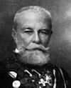 |  | 24 Jan 1894 - 2 Apr 1894 Djordje Simic (1st time)  (b. 1843 - d. 1921)
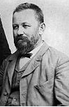 |  | 2 Apr 1894 - 27 Oct 1894 Svetomir Nikolajevic  (b. 1844 - d. 1922)
 |  | 27 Oct 1894 - 7 Jul 1895 Nikola Hristic (4th time) (s.a.)
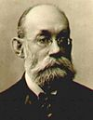 |  | 7 Jul 1895 - 29 Dec 1896 Stojan Novakovic (1st time)  (b. 1842 - d. 1915)
 |  | 29 Dec 1896 - 23 Oct 1897 Djordje Simic (2nd time) (s.a.)
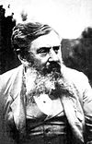 |  | 23 Oct 1897 - 24 Jul 1900 Vladan Djordjevic  (b. 1844 - d. 1930)
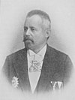 |  | 24 Jul 1900 - 2 Apr 1901 Aleksa Jovanovic  (b. 1846 - d. 1920)
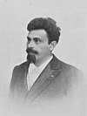 |  | 2 Apr 1901 - 20 Oct 1902 Mihailo Vujic  (b. 1853 - d. 1913)
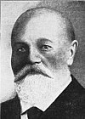 |  | 20 Oct 1902 - 19 Nov 1902 Pera Velimirovic (1st time)  (b. 1848 - d. 1922)
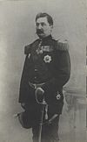 |  | 19 Nov 1902 - 11 Jun 1903 Dimitrije Cincar-Markovic  (b. 1849 - d. 1903)
 |  | 11 Jun 1903 - 4 Oct 1903 Jovan Avakumovic (2nd time) (s.a.)
 |  | 4 Oct 1903 - 10 Dec 1904 Sava Grujic (4th time) (s.a.)
 |  | 10 Dec 1904 - 29 May 1905 Nikola Pasic (2nd time) (s.a.)
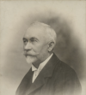 |  | 29 May 1905 - 14 Mar 1906 Ljubomir Stojanovic  (b. 1861 - d. 1930)
 |  | 14 Mar 1906 - 30 Apr 1906 Sava Grujic (5th time) (s.a.)
 |  | 30 Apr 1906 - 20 Jul 1908 Nikola Pasic (3rd time) (s.a.)
 |  | 20 Jul 1908 - 24 Feb 1909 Pera Velimirovic (2nd time) (s.a.)
 |  | 24 Feb 1909 - 24 Oct 1909 Stojan Novakovic (2nd time) (s.a.)
 |  | 24 Oct 1909 - 7 Jul 1911 Nikola Pasic (4th time) (s.a.)
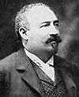 |  | 7 Jul 1911 - 1 Jul 1912 Milovan Milovanovic  (b. 1863 - d. 1912)
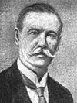 |  | 1 Jul 1912 - 12 Sep 1912 Marko Trifkovic  (b. 1864 - d. 1928)
12 Sep 1912 - 1 Dec 1918 Nikola Pasic (5th time) (s.a.)
(from Nov 1915 in Corfu exile)
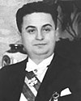 |  | 30 Apr 1941 - 29 Aug 1941 Milan Acimovic  (b. 1898 - d. 1945)  (president of the Council of Commissars)
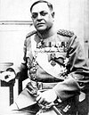 |  | 29 Aug 1941 - 10 Oct 1944 Milan Nedic  (b. 1877 - d. 1946)  (president of the Ministerial Council of the Serbian Government of National Salvation)
10 Oct 1944 - 20 Oct 1944 Ivan Petkovic
(head of Council of State Administration for Serbia)
18 Nov 1944 - 9 Apr 1945 Pavle Savic
(b. 1909 - d. 1994)
(commissar for restoration to Jan 1945, then head of
Economic Council)
 |  | 9 Apr 1945 - 5 Sep 1948 Blagoje Neskovic (s.a.)
 |  | 5 Sep 1948 - 5 Feb 1953 Petar Stambolic (s.a.)
Presidents of the Executive Council
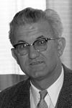 |  | 5 Feb 1953 - 16 Dec 1953 Petar Stambolic (s.a.)
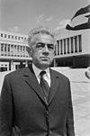 |  | 16 Dec 1953 - 6 Apr 1957 Jovan Veselinov (s.a.)
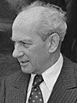 |  | 6 Apr 1957 - 9 Jun 1962 Milos Minic (s.a.)
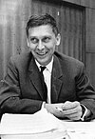 |  | 9 Jun 1962 - 6 Nov 1964 Slobodan Penezic Krcun  (b. 1918 - d. 1964)
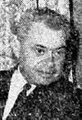 |  | 6 Nov 1964 - 17 Nov 1964 Stevan Doronjski (acting)  (b. 1919 - d. 1981)
17 Nov 1964 - 6 May 1967 Dragi Stamenkovic
(b. 1920 - d. 2004)
6 May 1967 - 6 May 1969 Djurica Jojkic
(b. 1914 - d. 1981)
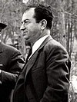 |  | 6 May 1969 - 6 May 1974 Milenko Bojanic  (b. 1924 - d. 1987)
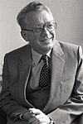 |  | 6 May 1974 - 6 May 1978 Dusan Ckrebic (s.a.)
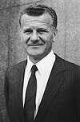 |  | 6 May 1978 - 5 May 1982 Ivan Stambolic (s.a.)
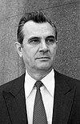 |  | 5 May 1982 - 6 May 1986 Branislav Ikonic  (b. 1928 - d. 2002)
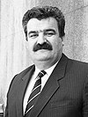 |  | 6 May 1986 - 5 Dec 1989 Desimir Jevtic  (b. 1938 - d. 2017)
5 Dec 1989 - 11 Feb 1991 Stanko Radmilovic
(b. 1936 - d. 2018)
Prime ministers
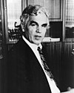 |  | 11 Feb 1991 - 23 Dec 1991 Dragutin Zelenovic  (b. 1928)
23 Dec 1991 - 10 Feb 1993 Radoman Bozovic (b. 1953)
10 Feb 1993 - 18 Mar 1994 Nikola Sainovic (b. 1948)
18 Mar 1994 - 24 Oct 2000 Mirko Marjanovic (b. 1937 - d. 2006)
24 Oct 2000 - 25 Jan 2001 Milomir Minic (b. 1950)
25 Jan 2001 - 12 Mar 2003 Zoran Djindjic (b. 1952 - d. 2003)
12 Mar 2003 - 16 Mar 2003 Nebojsa Covic (acting) (b. 1958)
17 Mar 2003 - 18 Mar 2003 Zarko Korac (acting) (b. 1947)
18 Mar 2003 - 3 Mar 2004 Zoran Zivkovic (b. 1960)
3 Mar 2004 - 7 Jul 2008 Vojislav Kostunica (b. 1944)
7 Jul 2008 - 27 Jul 2012 Mirko Cvetkovic (b. 1950)
27 Jul 2012 - 27 Apr 2014 Ivica Dacic (1st time) (b. 1966)
27 Apr 2014 - 31 May 2017 Aleksandar Vucic (s.a.)
31 May 2017 - 29 Jun 2017 Ivica Dacic (2nd time) (acting) (s.a.)
29 Jun 2017 - Ana Brnabic (f) (b. 1975)
Yugoslavia, and Serbia and Montenegro
1 Dec 1918 Kingdom of Serbs, Croats, and Slovenes (informally called
Yugoslavia)
3 Oct 1929 Kingdom of Yugoslavia
17 Apr 1941 state dissolved under Italian-German occupation
4 Dec 1943 state reconstituted as Democratic Federative Yugoslavia while
negotiations with royal government in exile continued
5 Mar 1945 accord with royal government
29 Nov 1945 Federative People's Republic of Yugoslavia
7 Apr 1963 Socialist Federative Republic of Yugoslavia
27 Apr 1992 Federal Republic of Yugoslavia established, consisting only
of Serbia and Montenegro, following secession of the other
four constituent republics
4 Feb 2003 replaced by a looser federation called Serbia and Montenegro
3 Jun 2006 Montenegro declares independence; Serbia acknowledges its
own independence on 5 Jun 2006, marking final end of union
Secretary-general of the Communist Party (from 7 Nov 1952, League of Communists)
Aug 1937 - Oct 1966 Josip Broz Tito (b. 1892 - d. 1980)
Presidents of the Presidium of the League of Communists
("leading role" abolished 22 Jan 1990)
Oct 1966 - 4 May 1980 Josip Broz Tito (s.a.)
19 Oct 1978 - 23 Oct 1979 Branko Mikulic (b. 1928 - d. 1994)
(acting for Tito)
23 Oct 1979 - 20 Oct 1980 Stevan Doronjski (b. 1919 - d. 1981)
(acting for Tito to 4 May 1980)
20 Oct 1980 - 20 Oct 1981 Lazar Mojsov (b. 1920 - d. 2011)
20 Oct 1981 - 29 Jun 1982 Dusan Dragosavac (b. 1919 - d. 2014)
29 Jun 1982 - 30 Jun 1983 Mitja Ribicic (b. 1919 - d. 2013)
30 Jun 1983 - 26 Jun 1984 Dragoslav Markovic (b. 1920 - d. 2005)
26 Jun 1984 - 25 Jun 1985 Ali Sukrija (b. 1919 - d. 2005)
25 Jun 1985 - 28 Jun 1986 Vidoje Zarkovic (b. 1927 - d. 2000)
28 Jun 1986 - 30 Jun 1987 Milanko Renovica (b. 1928 - d. 2013)
30 Jun 1987 - 30 Jun 1988 Bosko Krunic (b. 1929 - d. 2017)
30 Jun 1988 - 17 May 1989 Stipe Suvar (b. 1936 - d. 2004)
17 May 1989 - 17 May 1990 Milan Pancevski (b. 1935 - d. 2019)
17 May 1990 - 26 May 1990 Miomir Grbovic (acting)
Kings
- Karadjordjevic dynasty -
1 Dec 1918 - 16 Aug 1921 Petar I (s.a.)
1 Dec 1918 - 16 Aug 1921 Prince Aleksandar (regent) (s.a.)
16 Aug 1921 - 9 Oct 1934 Aleksandar I (s.a.)
9 Oct 1934 - 29 Nov 1945 Petar II (s.a.)
(in London [Oct 1943 - Mar 1944, Cairo] exile
from 13/14 Apr 1941)
9 Oct 1934 - 27 Mar 1941 Regency
- Prince Pavle (b. 1893 - d. 1976)
- Radenko Stankovic (b. 1880 - d. 1956)
- Ivo Perovic (b. 1881 - d. 1958)
2 Mar 1945 - 29 Nov 1945 Regency
- Srdjan Budisavljevic (b. 1883 - d. 1968)
- Dusan Sernec (b. 1882 - d. 1952)
- Ante Mandic (b. 1881 - d. 1959)
Chairman of the Anti-Fascist Council of National Liberation of Yugoslavia
26 Nov 1942 - 4 Dec 1943 Ivan Ribar (b. 1881 - d. 1968)
Chairman of the Presidium of the Provisional People's Assembly
4 Dec 1943 - 5 Mar 1945 Ivan Ribar (s.a.)
Chairman of the Presidium of the National Assembly
2 Dec 1945 - 14 Jan 1953 Ivan Ribar (s.a.)
President
14 Jan 1953 - 4 May 1980 Josip Broz Tito (s.a.)
Presidents of the Collective Presidency
4 May 1980 - 15 May 1980 Lazar Kolisevski (b. 1914 - d. 2000)
15 May 1980 - 15 May 1981 Cvijetin Mijatovic (b. 1913 - d. 1993)
15 May 1981 - 16 May 1982 Sergej Kraigher (b. 1914 - d. 2001)
16 May 1982 - 13 May 1983 Petar Stambolic (b. 1912 - d. 2007)
13 May 1983 - 15 May 1984 Mika Spiljak (b. 1916 - d. 2007)
15 May 1984 - 15 May 1985 Veselin Djuranovic (b. 1925 - d. 1997)
15 May 1985 - 15 May 1986 Radovan Vlajkovic (b. 1922 - d. 2001)
15 May 1986 - 15 May 1987 Sinan Hasani (b. 1922 - d. 2010)
15 May 1987 - 15 May 1988 Lazar Mojsov (s.a.)
15 May 1988 - 15 May 1989 Raif Dizdarevic (b. 1926)
15 May 1989 - 15 May 1990 Janez Drnovsek (b. 1950 - d. 2008)
15 May 1990 - 15 May 1991 Borisav Jovic (b. 1928)
15 May 1991 - 1 Jul 1991 vacant¹
1 Jul 1991 - 3 Oct 1991 Stipe Mesic (b. 1934)
3 Oct 1991 - 15 Jun 1992 Branko Kostic (acting) (b. 1939)
Presidents
15 Jun 1992 - 1 Jun 1993 Dobrica Cosic (b. 1921 - d. 2014)
1 Jun 1993 - 25 Jun 1993 Milos Radulovic (acting) (b. 1929)
25 Jun 1993 - 25 Jun 1997 Zoran Lilic (b. 1953)
25 Jun 1997 - 23 Jul 1997 Srdja Bozovic (acting) (b. 1955)
23 Jul 1997 - 7 Oct 2000 Slobodan Milosevic (b. 1941 - d. 2006)
7 Oct 2000 - 7 Mar 2003 Vojislav Kostunica (b. 1944)
7 Mar 2003 - 4 Jun 2006 Svetozar Marovic (b. 1955)
Prime ministers (15 Apr 1941 - Mar 1945 in exile²)
1 Dec 1918 - 22 Dec 1918 Nikola Pasic (1st time) (s.a.)
22 Dec 1918 - 16 Aug 1919 Stojan Protic (1st time) (b. 1857 - d. 1923)
16 Aug 1919 - 19 Feb 1920 Ljubomir Davidovic (1st time) (b. 1863 - d. 1940)
19 Feb 1920 - 16 May 1920 Stojan Protic (2nd time) (s.a.)
16 May 1920 - 1 Jan 1921 Milenko Vesnic (b. 1862 - d. 1921)
1 Jan 1921 - 28 Jul 1924 Nikola Pasic (2nd time) (s.a.)
28 Jul 1924 - 6 Nov 1924 Ljubomir Davidovic (2nd time) (s.a.)
6 Nov 1924 - 8 Apr 1926 Nikola Pasic (3rd time) (s.a.)
8 Apr 1926 - 17 Apr 1927 Nikola Uzunovic (1st time) (b. 1873 - d. 1954)
17 Apr 1927 - 28 Jul 1928 Velimir Vukicevic (b. 1871 - d. 1930)
28 Jul 1928 - 7 Jan 1929 Anton Korosec (b. 1872 - d. 1940)
7 Jan 1929 - 4 Apr 1932 Petar Zivkovic (b. 1879 - d. 1953)
4 Apr 1932 - 6 Jul 1932 Vojislav Marinkovic (b. 1876 - d. 1935)
6 Jul 1932 - 27 Jan 1934 Milan Srskic (b. 1880 - d. 1937)
27 Jan 1934 - 20 Dec 1934 Nikola Uzunovic (2nd time) (s.a.)
20 Dec 1934 - 24 Jun 1935 Bogoljub Jevtic (b. 1886 - d. 1960)
24 Jun 1935 - 5 Feb 1939 Milan Stojadinovic (b. 1888 - d. 1961)
5 Feb 1939 - 27 Mar 1941 Dragisa Cvetkovic (b. 1893 - d. 1969)
27 Mar 1941 - 11 Jan 1942 Dusan T. Simovic (b. 1882 - d. 1962)
11 Jan 1942 - 26 Jun 1943 Slobodan Jovanovic (b. 1869 - d. 1958)
26 Jun 1943 - 10 Aug 1943 Milos Trifunovic (b. 1871 - d. 1957)
10 Aug 1943 - 1 Jun 1944 Bozidar Puric (b. 1891 - d. 1977)
Chairmen of the Executive Council of the Anti-Fascist
Council of National Liberation of Yugoslavia:
27 Nov 1942 - 30 Nov 1943 Ivan Ribar (s.a.)
30 Nov 1943 - 7 Mar 1945 Josip Broz Tito (s.a.)
1 Jun 1944 - 7 Mar 1945 Ivan Subasic (b. 1892 - d. 1955)
7 Mar 1945 - 14 Jan 1953 Josip Broz Tito (s.a.)
Presidents of the Federal Executive Council (premiers)
14 Jan 1953 - 29 Jun 1963 Josip Broz Tito (s.a.)
29 Jun 1963 - 18 May 1967 Petar Stambolic (s.a.)
18 May 1967 - 17 May 1969 Mika Spiljak (s.a.)
17 May 1969 - 30 Jul 1971 Mitja Ribicic (s.a.)
30 Jul 1971 - 18 Jan 1977 Dzemal Bijedic (b. 1917 - d. 1977)
14 Feb 1977 - 16 May 1982 Veselin Djuranovic (s.a.)
16 May 1982 - 15 May 1986 Milka Planinc (f) (b. 1924 - d. 2010)
15 May 1986 - 16 Mar 1989 Branko Mikulic (s.a.)
16 Mar 1989 - 20 Dec 1991 Ante Markovic (b. 1924 - d. 2011)
20 Dec 1991 - 14 Jul 1992 Aleksandar Mitrovic (acting) (b. 1933 - d. 2012)
Prime ministers
14 Jul 1992 - 9 Feb 1993 Milan Panic (b. 1929)
9 Feb 1993 - 19 May 1998 Radoje Kontic (b. 1937)
19 May 1998 - 4 Nov 2000 Momir Bulatovic (b. 1956)
4 Nov 2000 - 24 Jul 2001 Zoran Zizic (b. 1951 - d. 2013)
24 Jul 2001 - 17 Mar 2003 Dragisa Pesic (b. 1954 - d. 2016)
¹The members of the Presidency during this interval were Borisav Jovic (s.a.), Stipe Mesic (s.a.), Momir Bulatovic (s.a.) (to 16 May 1991), Branko Kostic (s.a.) (from 16 May 1991), Jugoslav Kostic (b. 1939), Vukasin Jokanovic (b. 1939) (to 16 May 1991), Sejdo Bajramovic (b. 1927 - d. 1993) (from 16 May 1991), Vasil Tupurkovski (b. 1951), Bogic Bogicevic (b. 1953?), and Janez Drnovsek (s.a.). On 17 May 1991 Bajramovic was elected coordinator of the presidency.
²Greece 15-28 Apr 1941, Palestine 28 Apr - Jun 1941, London Jun 1941 - Sep 1943 and Mar 1944 - Mar 1945, Cairo Sep 1943 - Mar 1944.
Vojvodina
24 Nov 1918 - 11 Mar 1919 autonomy
1945 Autonomous Province of Vojvodina
1963 Socialist Autonomous Province of Vojvodina
28 Sep 1990 Autonomous Province of Vojvodina
Chairmen of the Provincial Committee of the Communist Party
(from 1952, League of Communists)
1943 Isa Jovanovic (b. 1906 - d. 1983)
1943 - 1946 Jovan Veselinov (b. 1907 - d. 1982)
1946 - May 1951 Dobrivoje Vidic (b. 1918 - d. 1991)
May 1951 - 1966 Stevan Doronjski (b. 1919 - d. 1981)
1966 - 1969 Mirko Tepavac (b. 1922 - d. 2014)
1969 - 24 Dec 1972 Mirko Canadanovic (b. 1936)
24 Dec 1972 - 28 Apr 1981 Dusan Alimpic (b. 1921 - d. 2002)
28 Apr 1981 - 28 Apr 1982 Bosko Krunic (1st time) (b. 1929 - d. 2017)
28 Apr 1982 - 28 Apr 1983 Marko Djuricin (b. 1925 - d. 2013)
28 Apr 1983 - 28 Apr 1984 Slavko Veselinov (b. 1925)
28 Apr 1984 - 24 Apr 1985 Bosko Krunic (2nd time) (s.a.)
24 Apr 1985 - 1988 Djordje Stojsic (b. 1928 - d. 2014)
1988 - 6 Oct 1988 Milovan Sogorov (b. 1941)
14 Nov 1988 - 20 Jan 1989 Bosko Kovacevic (b. 1946)
20 Jan 1989 - 16 Jul 1990 Nedeljko Sipovac (b. 1942)
President of the Great National Assembly
24 Nov 1918 - 11 Mar 1919 Jovan Lalosevic (b. 1870 - d. 1935)
Chairman of the People's Defense Committee
Nov 1943 - 1945 Nikola Grulovic (b. 1888 - d. 1959)
Presidents of the People's Assembly
1945 - Jul 1947 Jovan Veselinov (s.a.)
Jul 1947 - Dec 1953 Luka Mrksic (b. 1899 - d. 1976)
Dec 1953 - 18 Jul 1963 Stevan Doronjski (s.a.)
18 Jul 1963 - 20 Apr 1967 Radovan Vlajkovic (b. 1922 - d. 2001)
20 Apr 1967 - 5 Jun 1973 Ilija Rajacic (b. 1923 - d. 2005)
5 Jun 1973 - Nov 1974 Sreta Kovacevic (b. 1920 - d. 1995)
Presidents of the Presidency
Nov 1974 - Nov 1981 Radovan Vlajkovic (s.a.)
Nov 1981 - May 1982 Predrag Vladisavljevic (1st time) (b. 1919)
May 1982 - May 1983 Danilo Kekic (b. 1918)
May 1983 - 4 May 1984 Djordje Radosavljevic (1st time) (b. 1921)
4 May 1984 - 7 May 1985 Nandor Major (1st time) (b. 1931)
7 May 1985 - May 1986 Predrag Vladisavljevic (2nd time) (s.a.)
May 1986 - May 1988 Djordje Radosavljevic (2nd time) (s.a.)
May 1988 - May 1989 Nandor Major (2nd time) (s.a.)
May 1989 - Jan 1991 Jugoslav Kostic (b. 1939)
Presidents of the Assembly
1991 Verona Adam Bokros (f) (b. 1948)
1991 - 1992 Damnjan Radenkovic (b. 1939)
1992 - 1993 Svetislav Krstic (b. 1955)
1993 - 9 Jan 1997 Milutin Stojkovic (b. 1942)
9 Jan 1997 - 23 Oct 2000 Zivorad Smiljanic (b. 1942 - d. 2018)
23 Oct 2000 - 30 Oct 2004 Nenad Canak (b. 1959)
30 Oct 2004 - 16 Jul 2008 Bojan Kostres (b. 1974)
16 Jul 2008 - 22 Jun 2012 Sandor Egeresi (b. 1964)
22 Jun 2012 - Istvan Pastor (b. 1956)
President of the Great People's Council
24 Nov 1918 - 11 Mar 1919 Slavko Miletic (b. 1869 - d. 1934)
Prime ministers
1945 - 1947 Aleksandar Sevic (b. 1897 - d. 1975)
1947 - 20 Mar 1953 Luka Mrksic (s.a.)
Chairmen of the Executive Council
20 Mar 1953 - Dec 1953 Stevan Doronjski (s.a.)
Dec 1953 - 22 Jul 1962 Geza Tikvicki (b. 1917 - d. 1999)
22 Jul 1962 - 18 Jul 1963 Djurica Jojkic (b. 1914 - d. 1981)
18 Jul 1963 - 20 Apr 1967 Ilija Rajacic (s.a.)
20 Apr 1967 - Oct 1971 Stipan Marusic (b. 1926 - d. 1974)
Oct 1971 - 6 May 1974 Franjo Nadj (b. 1923 - d. 1986)
6 May 1974 - 5 May 1982 Nikola Kmezic (b. 1919 - d. 2009)
5 May 1982 - May 1986 Zivan Marelj (b. 1938)
May 1986 - 24 Oct 1989 Jon Srbovan (b. 1930 - d. 2018)
24 Oct 1989 - 1989 Sredoje Erdeljan (b. 1939 - d. 2011)
1989 - 1991 Jovan Radic (b. 1949)
1991 - 23 Dec 1991 Radoman Bozovic (b. 1953)
1992 - 1993 Koviljko Lovre (b. 1954)
1993 - 13 May 2000 Bosko Perosevic (b. 1956 - d. 2000)
13 May 2000 - 23 Oct 2000 Damnjan Radenkovic (s.a.)
(acting to 29 Jun 2000)
23 Oct 2000 - 30 Oct 2004 Djordje Djukic (b. 1948)
30 Oct 2004 - 14 Dec 2009 Bojan Pajtic (b. 1970)
Chairmen of the Government
14 Dec 2009 - 20 Jun 2016 Bojan Pajtic (s.a.)
20 Jun 2016 - Igor Mirovic (b. 1968)

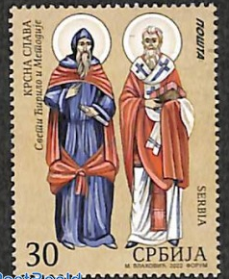 | 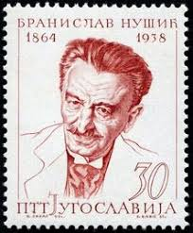
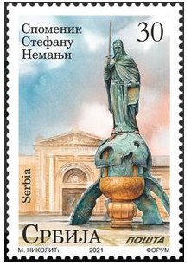

INCLUDEPICTURE "http://t0.gstatic.com/images?q=tbn:ANd9GcTDT1jpfS6n_Y4NmsXFnf0dV2uAk854tEHeOSaIXPxUCt7qxHu5xaSaZA" \* MERGEFORMATINET INCLUDEPICTURE "http://t0.gstatic.com/images?q=tbn:ANd9GcTDT1jpfS6n_Y4NmsXFnf0dV2uAk854tEHeOSaIXPxUCt7qxHu5xaSaZA" \* MERGEFORMATINET INCLUDEPICTURE "http://t0.gstatic.com/images?q=tbn:ANd9GcTDT1jpfS6n_Y4NmsXFnf0dV2uAk854tEHeOSaIXPxUCt7qxHu5xaSaZA" \* MERGEFORMATINET INCLUDEPICTURE "http://t0.gstatic.com/images?q=tbn:ANd9GcTDT1jpfS6n_Y4NmsXFnf0dV2uAk854tEHeOSaIXPxUCt7qxHu5xaSaZA" \* MERGEFORMATINET INCLUDEPICTURE "http://t0.gstatic.com/images?q=tbn:ANd9GcTDT1jpfS6n_Y4NmsXFnf0dV2uAk854tEHeOSaIXPxUCt7qxHu5xaSaZA" \* MERGEFORMATINET INCLUDEPICTURE "http://t0.gstatic.com/images?q=tbn:ANd9GcTDT1jpfS6n_Y4NmsXFnf0dV2uAk854tEHeOSaIXPxUCt7qxHu5xaSaZA" \* MERGEFORMATINET INCLUDEPICTURE "http://t0.gstatic.com/images?q=tbn:ANd9GcTDT1jpfS6n_Y4NmsXFnf0dV2uAk854tEHeOSaIXPxUCt7qxHu5xaSaZA" \* MERGEFORMATINET INCLUDEPICTURE "http://t0.gstatic.com/images?q=tbn:ANd9GcTDT1jpfS6n_Y4NmsXFnf0dV2uAk854tEHeOSaIXPxUCt7qxHu5xaSaZA" \* MERGEFORMATINET INCLUDEPICTURE "http://t0.gstatic.com/images?q=tbn:ANd9GcTDT1jpfS6n_Y4NmsXFnf0dV2uAk854tEHeOSaIXPxUCt7qxHu5xaSaZA" \* MERGEFORMATINET INCLUDEPICTURE "http://t0.gstatic.com/images?q=tbn:ANd9GcTDT1jpfS6n_Y4NmsXFnf0dV2uAk854tEHeOSaIXPxUCt7qxHu5xaSaZA" \* MERGEFORMATINET INCLUDEPICTURE "http://t0.gstatic.com/images?q=tbn:ANd9GcTDT1jpfS6n_Y4NmsXFnf0dV2uAk854tEHeOSaIXPxUCt7qxHu5xaSaZA" \* MERGEFORMATINET INCLUDEPICTURE "http://t0.gstatic.com/images?q=tbn:ANd9GcTDT1jpfS6n_Y4NmsXFnf0dV2uAk854tEHeOSaIXPxUCt7qxHu5xaSaZA" \* MERGEFORMATINET INCLUDEPICTURE "http://t0.gstatic.com/images?q=tbn:ANd9GcTDT1jpfS6n_Y4NmsXFnf0dV2uAk854tEHeOSaIXPxUCt7qxHu5xaSaZA" \* MERGEFORMATINET INCLUDEPICTURE "http://t0.gstatic.com/images?q=tbn:ANd9GcTDT1jpfS6n_Y4NmsXFnf0dV2uAk854tEHeOSaIXPxUCt7qxHu5xaSaZA" \* MERGEFORMATINET INCLUDEPICTURE "http://t0.gstatic.com/images?q=tbn:ANd9GcTDT1jpfS6n_Y4NmsXFnf0dV2uAk854tEHeOSaIXPxUCt7qxHu5xaSaZA" \* MERGEFORMATINET INCLUDEPICTURE "http://t0.gstatic.com/images?q=tbn:ANd9GcTDT1jpfS6n_Y4NmsXFnf0dV2uAk854tEHeOSaIXPxUCt7qxHu5xaSaZA" \* MERGEFORMATINET INCLUDEPICTURE "http://t0.gstatic.com/images?q=tbn:ANd9GcTDT1jpfS6n_Y4NmsXFnf0dV2uAk854tEHeOSaIXPxUCt7qxHu5xaSaZA" \* MERGEFORMATINET INCLUDEPICTURE "http://t0.gstatic.com/images?q=tbn:ANd9GcTDT1jpfS6n_Y4NmsXFnf0dV2uAk854tEHeOSaIXPxUCt7qxHu5xaSaZA" \* MERGEFORMATINET INCLUDEPICTURE "http://t0.gstatic.com/images?q=tbn:ANd9GcTDT1jpfS6n_Y4NmsXFnf0dV2uAk854tEHeOSaIXPxUCt7qxHu5xaSaZA" \* MERGEFORMATINET INCLUDEPICTURE "http://t0.gstatic.com/images?q=tbn:ANd9GcTDT1jpfS6n_Y4NmsXFnf0dV2uAk854tEHeOSaIXPxUCt7qxHu5xaSaZA" \* MERGEFORMATINET INCLUDEPICTURE "http://t0.gstatic.com/images?q=tbn:ANd9GcTDT1jpfS6n_Y4NmsXFnf0dV2uAk854tEHeOSaIXPxUCt7qxHu5xaSaZA" \* MERGEFORMATINET INCLUDEPICTURE "http://t0.gstatic.com/images?q=tbn:ANd9GcTDT1jpfS6n_Y4NmsXFnf0dV2uAk854tEHeOSaIXPxUCt7qxHu5xaSaZA" \* MERGEFORMATINET INCLUDEPICTURE "http://t0.gstatic.com/images?q=tbn:ANd9GcTDT1jpfS6n_Y4NmsXFnf0dV2uAk854tEHeOSaIXPxUCt7qxHu5xaSaZA" \* MERGEFORMATINET INCLUDEPICTURE "http://t0.gstatic.com/images?q=tbn:ANd9GcTDT1jpfS6n_Y4NmsXFnf0dV2uAk854tEHeOSaIXPxUCt7qxHu5xaSaZA" \* MERGEFORMATINET INCLUDEPICTURE "http://t0.gstatic.com/images?q=tbn:ANd9GcTDT1jpfS6n_Y4NmsXFnf0dV2uAk854tEHeOSaIXPxUCt7qxHu5xaSaZA" \* MERGEFORMATINET INCLUDEPICTURE "http://t0.gstatic.com/images?q=tbn:ANd9GcTDT1jpfS6n_Y4NmsXFnf0dV2uAk854tEHeOSaIXPxUCt7qxHu5xaSaZA" \* MERGEFORMATINET INCLUDEPICTURE "http://t0.gstatic.com/images?q=tbn:ANd9GcTDT1jpfS6n_Y4NmsXFnf0dV2uAk854tEHeOSaIXPxUCt7qxHu5xaSaZA" \* MERGEFORMATINET INCLUDEPICTURE "http://t0.gstatic.com/images?q=tbn:ANd9GcTDT1jpfS6n_Y4NmsXFnf0dV2uAk854tEHeOSaIXPxUCt7qxHu5xaSaZA" \* MERGEFORMATINET INCLUDEPICTURE "http://t0.gstatic.com/images?q=tbn:ANd9GcTDT1jpfS6n_Y4NmsXFnf0dV2uAk854tEHeOSaIXPxUCt7qxHu5xaSaZA" \* MERGEFORMATINET INCLUDEPICTURE "http://t0.gstatic.com/images?q=tbn:ANd9GcTDT1jpfS6n_Y4NmsXFnf0dV2uAk854tEHeOSaIXPxUCt7qxHu5xaSaZA" \* MERGEFORMATINET INCLUDEPICTURE "http://t0.gstatic.com/images?q=tbn:ANd9GcTDT1jpfS6n_Y4NmsXFnf0dV2uAk854tEHeOSaIXPxUCt7qxHu5xaSaZA" \* MERGEFORMATINET INCLUDEPICTURE "http://t0.gstatic.com/images?q=tbn:ANd9GcTDT1jpfS6n_Y4NmsXFnf0dV2uAk854tEHeOSaIXPxUCt7qxHu5xaSaZA" \* MERGEFORMATINET INCLUDEPICTURE "http://t0.gstatic.com/images?q=tbn:ANd9GcTDT1jpfS6n_Y4NmsXFnf0dV2uAk854tEHeOSaIXPxUCt7qxHu5xaSaZA" \* MERGEFORMATINET INCLUDEPICTURE "http://t0.gstatic.com/images?q=tbn:ANd9GcTDT1jpfS6n_Y4NmsXFnf0dV2uAk854tEHeOSaIXPxUCt7qxHu5xaSaZA" \* MERGEFORMATINET INCLUDEPICTURE "http://t0.gstatic.com/images?q=tbn:ANd9GcTDT1jpfS6n_Y4NmsXFnf0dV2uAk854tEHeOSaIXPxUCt7qxHu5xaSaZA" \* MERGEFORMATINET INCLUDEPICTURE "http://t0.gstatic.com/images?q=tbn:ANd9GcTDT1jpfS6n_Y4NmsXFnf0dV2uAk854tEHeOSaIXPxUCt7qxHu5xaSaZA" \* MERGEFORMATINET INCLUDEPICTURE "http://t0.gstatic.com/images?q=tbn:ANd9GcTDT1jpfS6n_Y4NmsXFnf0dV2uAk854tEHeOSaIXPxUCt7qxHu5xaSaZA" \* MERGEFORMATINET INCLUDEPICTURE "http://t0.gstatic.com/images?q=tbn:ANd9GcTDT1jpfS6n_Y4NmsXFnf0dV2uAk854tEHeOSaIXPxUCt7qxHu5xaSaZA" \* MERGEFORMATINET INCLUDEPICTURE "http://t0.gstatic.com/images?q=tbn:ANd9GcTDT1jpfS6n_Y4NmsXFnf0dV2uAk854tEHeOSaIXPxUCt7qxHu5xaSaZA" \* MERGEFORMATINET INCLUDEPICTURE "http://t0.gstatic.com/images?q=tbn:ANd9GcTDT1jpfS6n_Y4NmsXFnf0dV2uAk854tEHeOSaIXPxUCt7qxHu5xaSaZA" \* MERGEFORMATINET INCLUDEPICTURE "http://t0.gstatic.com/images?q=tbn:ANd9GcTDT1jpfS6n_Y4NmsXFnf0dV2uAk854tEHeOSaIXPxUCt7qxHu5xaSaZA" \* MERGEFORMATINET INCLUDEPICTURE "http://t0.gstatic.com/images?q=tbn:ANd9GcTDT1jpfS6n_Y4NmsXFnf0dV2uAk854tEHeOSaIXPxUCt7qxHu5xaSaZA" \* MERGEFORMATINET INCLUDEPICTURE "http://t0.gstatic.com/images?q=tbn:ANd9GcTDT1jpfS6n_Y4NmsXFnf0dV2uAk854tEHeOSaIXPxUCt7qxHu5xaSaZA" \* MERGEFORMATINET INCLUDEPICTURE "http://t0.gstatic.com/images?q=tbn:ANd9GcTDT1jpfS6n_Y4NmsXFnf0dV2uAk854tEHeOSaIXPxUCt7qxHu5xaSaZA" \* MERGEFORMATINET INCLUDEPICTURE "http://t0.gstatic.com/images?q=tbn:ANd9GcTDT1jpfS6n_Y4NmsXFnf0dV2uAk854tEHeOSaIXPxUCt7qxHu5xaSaZA" \* MERGEFORMATINET INCLUDEPICTURE "http://t0.gstatic.com/images?q=tbn:ANd9GcTDT1jpfS6n_Y4NmsXFnf0dV2uAk854tEHeOSaIXPxUCt7qxHu5xaSaZA" \* MERGEFORMATINET INCLUDEPICTURE "http://t0.gstatic.com/images?q=tbn:ANd9GcTDT1jpfS6n_Y4NmsXFnf0dV2uAk854tEHeOSaIXPxUCt7qxHu5xaSaZA" \* MERGEFORMATINET INCLUDEPICTURE "http://t0.gstatic.com/images?q=tbn:ANd9GcTDT1jpfS6n_Y4NmsXFnf0dV2uAk854tEHeOSaIXPxUCt7qxHu5xaSaZA" \* MERGEFORMATINET INCLUDEPICTURE "http://t0.gstatic.com/images?q=tbn:ANd9GcTDT1jpfS6n_Y4NmsXFnf0dV2uAk854tEHeOSaIXPxUCt7qxHu5xaSaZA" \* MERGEFORMATINET

Compiler FLN

